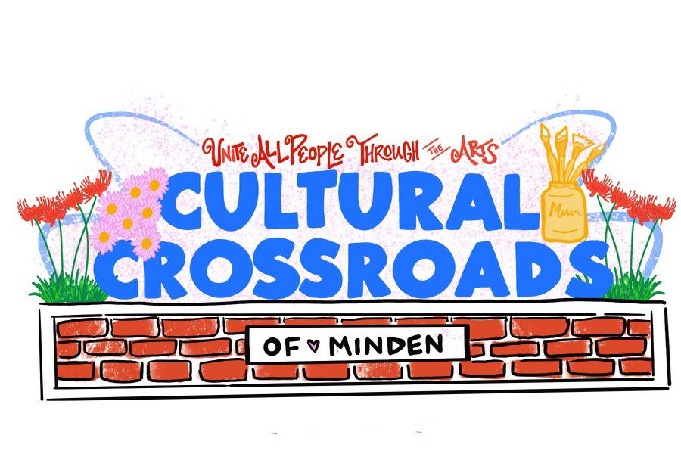

| PRIVATE EVENT FARM RENTAL FEES Grounds only $150.00  Pavilion and grounds $300.00  Zenobia’s House (studio) $250.00  Zenobia’s House, Pavilion, &  Grounds $500.00  Parking Lot (Day Rental) $50.00 PUBLIC EVENT FARM RENTAL FEES Public Event $500.00  (Does not include use of Zenobia’s  House/Studio)  Community Organization Rental  (rate excludes events)  No more than 20 attendees   Rent up to 3 hours. $25 hourly  rental any additional hour $5 per  hour.  Private Rentals are invitation only.  Any event that is open to the public, whether free of charge or allows admission through the sale of tickets, gate or cover fees, or has an attendance greater than 100 guests constitutes as a Public Rental. All Public Rentals require event insurance & security as outlined on Page 2.  These are daily rates based on occupancy that begin as early as 7 am and end at 11:30 pm, with facilities being cleaned & restored to original condition and gates locked no later than 12 midnight.  Parking lot rentals do not include use of the bathroom and should end no later than 9 PM.  CONTACT  Email: [CulturalCrossroadsOfMinden@gmail.com](mailto:CulturalCrossroadsOfMinden@gmail.com)  Phone: 318-268-6535  Find us on FB :  The Farm of Cultural Crossroads  Website: www.culturalcrossroadsofminden.org |  | The Farm Of Cultural Crossroads *RENTAL AGREEMENT**DATE(S) RENTED: _____________________________________________________* *Timeframe of Event:_________________________________________________*  *Responsible Individual:______________________________________________*  *Responsible Individual License or ID Number: __________________________*  *Address:____________________________________________________________*  *_____________________________________________________________________*  *Email: _________________________________Cell phone___________________*  *Event Description:___________________________________________________*  *Number of Expected Guests:________________________________________*   *RENTAL DEPOSIT REQUIRED: Reservations are not guaranteed until deposit is paid in full no less than two weeks prior to rental. Deposit is nonrefundable in event of cancellation.*  *Private event deposit - $150.00**Public event deposit - $500.00* ***Parking Lot - $50.00***  ***Community Organization Rental - $25.00***  *The deposit will be returned the following business day after the event and following any clean up and following a full inspection assuming no damage has occurred. (Conditions included on separate sheet)*  *Rental fee is due in full no less than two weeks prior to the event.*  *It is also understood that those mentioned above will be held responsible and liable for any damages to the Farm or Farm property as a result of their activity during the scheduled event. This includes attorney fees & court costs.*  *Responsible Individual certifies that all information given is accurate and that they are 21 years of age or older. ID will be checked for verification. Any changes to the event must be communicated with a Cultural Crossroads Board Member immediately.*  *_______________________________________________ Date_____________*  *Responsible Individual’s Signature*  *________________________________________________Date_____________*  *Cultural Crossroads Board Member* |
| --- | --- | --- |

**RENTAL AGREEMENT for The Farm of Cultural Crossroads**

Located at 419 East Union (Hwy 80) in Minden, Louisiana

The following rental conditions were made. $_______ Deposit will be refunded following inspection and approved by an authorized Board Member.

IN THE EVENT OF CANCELLATION, THE DEPOSIT IS NON-REFUNDABLE.

**CLEAN UP OF THE FARM following the event includes the following:**

* Cleaning the grounds. This includes picking up any trash in and around the event area.
* Depositing the trash in the trash cans near the back gate and delivering the cans to the curb for pick up.
* Putting everything back in its original place, i.e. tables, chairs, benches, etc.
* Clean the bathrooms and bring them back to their original condition.

**PRIVATE PARTIES do not require additional event insurance, unless alcohol is served or allowed. Security will also be required for all private rentals if alcohol is consumed on the premises.** However, public events such as fairs, festivals, family reunions and class reunions will require separate event insurance in all cases.

A copy of the event insurance is required no later than one week prior to the event date.

If organizers fail to provide proof of insurance, the event will be canceled and the deposit forfeited.

**Security must be provided** in the form of hired off-duty Police Officers or Sheriff’s Deputies. This is for any event open to the public and *held after 6pm*. There shall be 1 police officer providing security if there are 100 attendees or less. If the planners of the event anticipate more than 100 attendees, no less than 2 police officers must be present. Names of Officers or Deputies that will be providing security must be given to the Executive Director or other Cultural Crossroads Representative prior to the event. Security may not leave the premises until facilities have been locked up by the responsible individual.

Cultural Crossroads of Minden, Inc. reserves the right to cancel or end any rental at any time for failure to meet the rental requirements, for disorderly conduct during the rental, or use of unauthorized space. This will result in a forfeiture of the deposit.

Additional conditions: _________________________________________________________________

Dated ___________ and Signed by both parties:

__________________________________________ ____________________________________________

*Responsible Individual Cultural Crossroads Board Member*